Instructions for operating PFP Multi-Channel Logger using PicoScope 3406D & MATLAB.

PFPCyberSecurity provides a simplistic multi-channel data logger intended to provide users with the ability simultaneously collect side channel observations from multiple sources to allow researchers to easily collect data for analysis. Once the data has been collected the user simply uploads the data to the PFP Cloud Storage Server for analysis using the PFP Cybersecurity ftp server. The logger code base (source code) is open source and available for general use. The logger application can be modified by the user to satisfy their application specific requirements if needed. The key components that the user must adhere to when modifying the code base is the data output format, which is in SigMF0.0.1PFPExtensionsV1.0.2 format.

The PFP Logger is written using MATLAB (R2016b), and PicoScope support functions from their SDK. The logger basically operates similar to an Oscilloscope, but allows the user to setup up parameters such that the data collection is automated and capture waveforms are logged. MATLAB, MATLAB Instrument Control Toolbox, install of PicoScope 3000 series SDK (https://www.picotech.com/downloads), and a PicoScope 3406D are required.

**Multi-Channel Logger Overview**

The multi-channel logger application was developed to enable researches a simplistic DAQ system to encourage the collection of side channel observations on many devices. The logger is intended to remove the DAQ development burden from the researcher so that their efforts are focused on signal processing and algorithm development. The enhanced capability of simultaneously recording multiple channels will allow the researcher to increase the number of observables from which to extract additional features. These additional observables and features will lead to the development of more accurate and resilient detection methods. The logger has two modes of operation, one mode is synchronous sampling where the collected data is synchronized to an external source. The second mode is a streaming mode where once the data collection process is started if will run continuously until the user halts the process. In streaming mode the samples are limited to 1MHz and below.

**Typical collection process**

The typical data acquisition process is to repetitively sample waveforms for each State of the Device Under Test (DUT) that are of interest to the user. These repetitive waveforms will ultimately be used by for training by the SaaS Machine Learning analytics engine. The sampled time series of a State is referred to as a trace. Enough of these times series traces are collected in order to compute the required statistical characteristics of the given State. Ideally each cycle of the State will be identical within a reasonable amount of uncertainty but as with many systems the execution paths can be different due to interrupts, operating system schedulers, context switching, and other sub-systems within the DUT.

**Hardware Connections**

The following diagram shows the connection layout of an RF probe, amplifier, trigger and PicoScope:

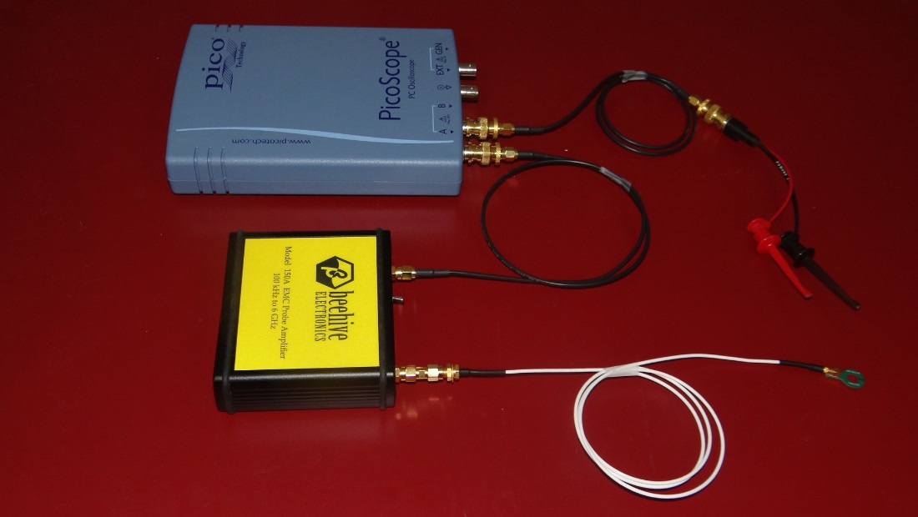

This diagram shows the connection layout attached to a micro controller ready for use:

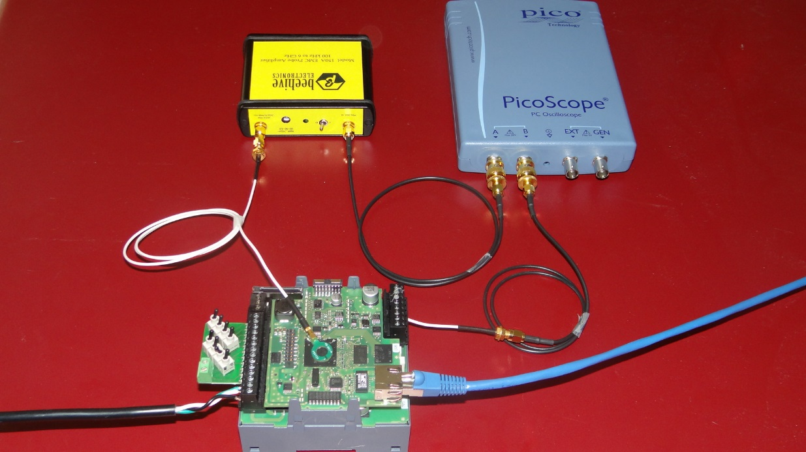

To run the Logger.

1. Unzip the contents of the PFPPicoLogger.zip.
2. Install PicoScope series 3000 SDK.
3. Open MATLAB.
4. In MATLAB, navigate to the directory where “PFPPicoLogger” was extracted.
5. Make the necessary hardware connections.
6. At the MATLAB command prompt, type “Pico3406DLogger”, hit return. This should open the initial GUI.

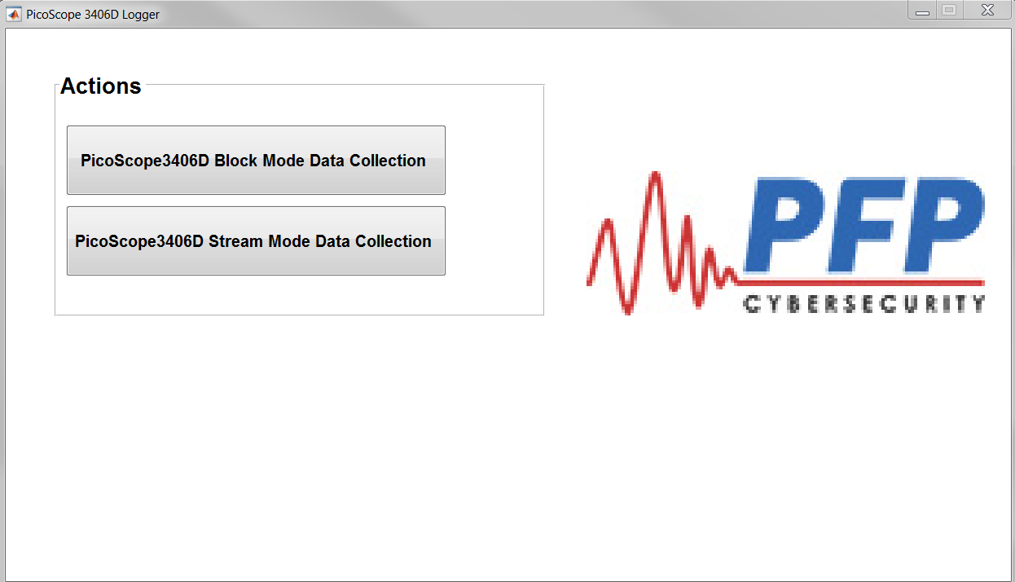

1. Click on the PicoScope3406D Block Mode Data Collection button. This will prompted the user to navigate to a directory where the Configuration file is located. A default Configuration file (PicoScope3406DDAQconfig.json) is located in the Support directory.

The configuration file contains setting for the initial configuration parameters for the logger. Do not open the file to make changes, changes are made using the supplied GUI.

1. After the user selects the configuration file, the following GUI should be open.

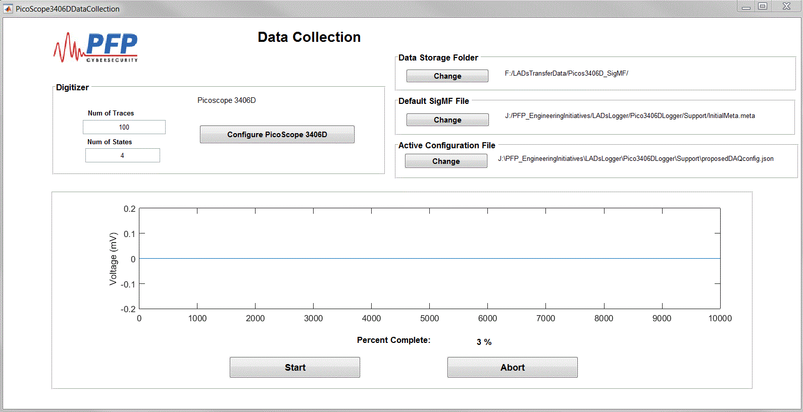

From the Data Collection GUI, the user can modify the defaults file options, modify Digitizer collection options, Configure the PicoScope 3406D or start the data collection process. It this is a new collection, it is advisable to first configure the PicoScope 3406D to ensure the PicoScope is configured correctly for the user’s application. To configure the PicoScope 3406D select the “Configure PicoScope 3406D” button. This will bring the user to the following GUI.

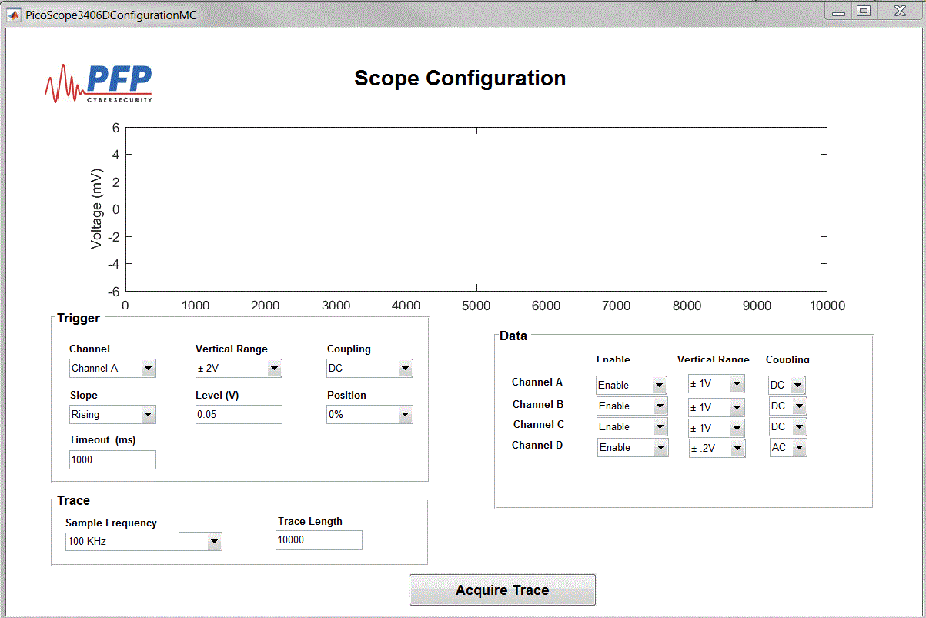

From this GUI the user can modify sampling parameters and observe the waveforms. Visually observing the waveforms can help ensure that PicoScope is correctly setup to the application. Once the sampling parameters a set, closing the GUI will prompt the user to either save the current settings or discard them and bring the user back to the Data Collection GUI.

Once the user is back at the Data Collection GUI and is satisfied with the Data Collection parameters they can initiate the data acquisition by selecting the Start button. The user will be prompted to that all data in the storage directory will be deleted.

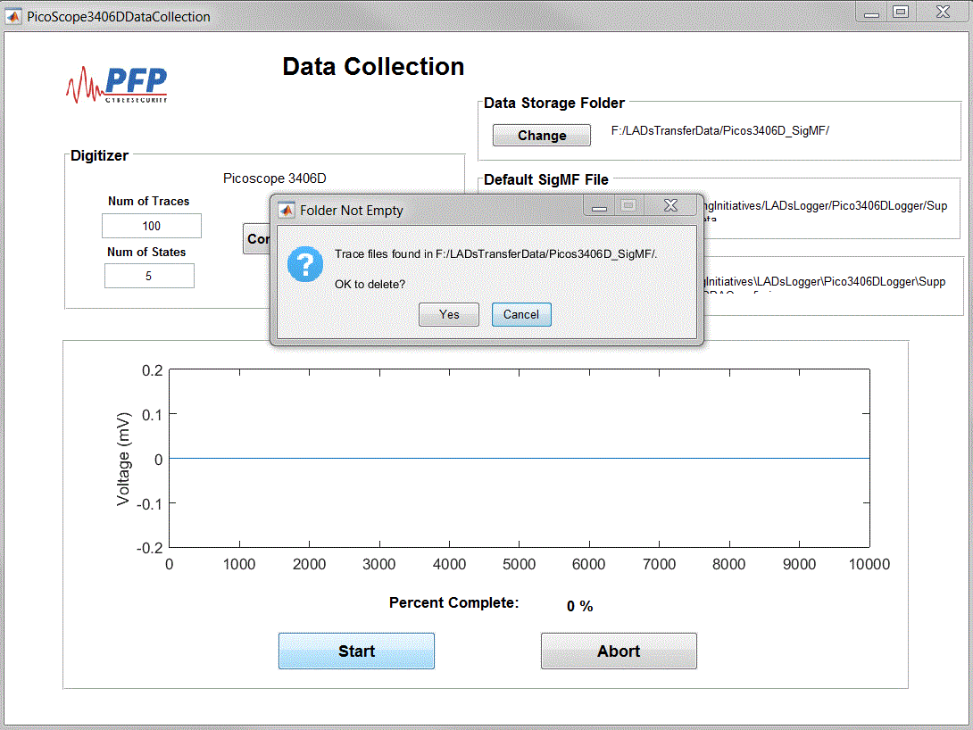

Next the user will be prompted to place the DUT in the desired State and continue with the data collection process.

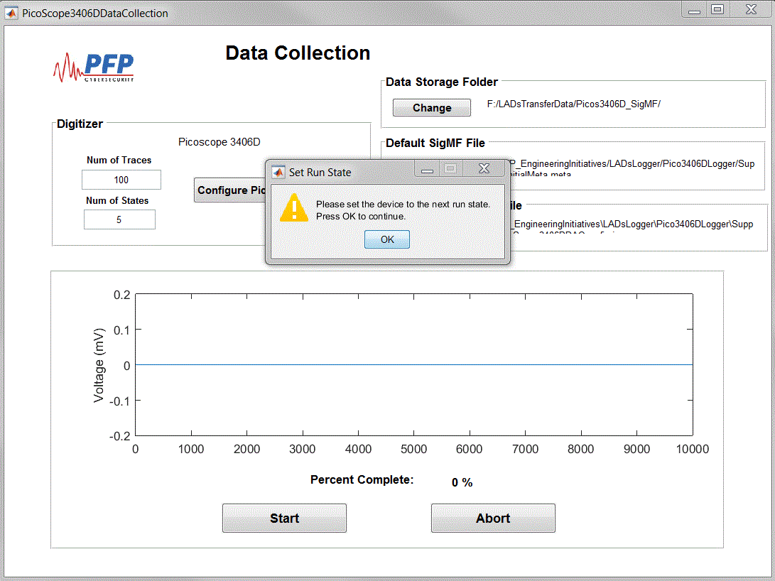

Once the data collection for the given State is completed the user will be prompted to change the DUT to the next State. After all State data is collected the will be prompted that the process is complete. The PFP Logger will write all the necessary files for analysis in the user specified directory.

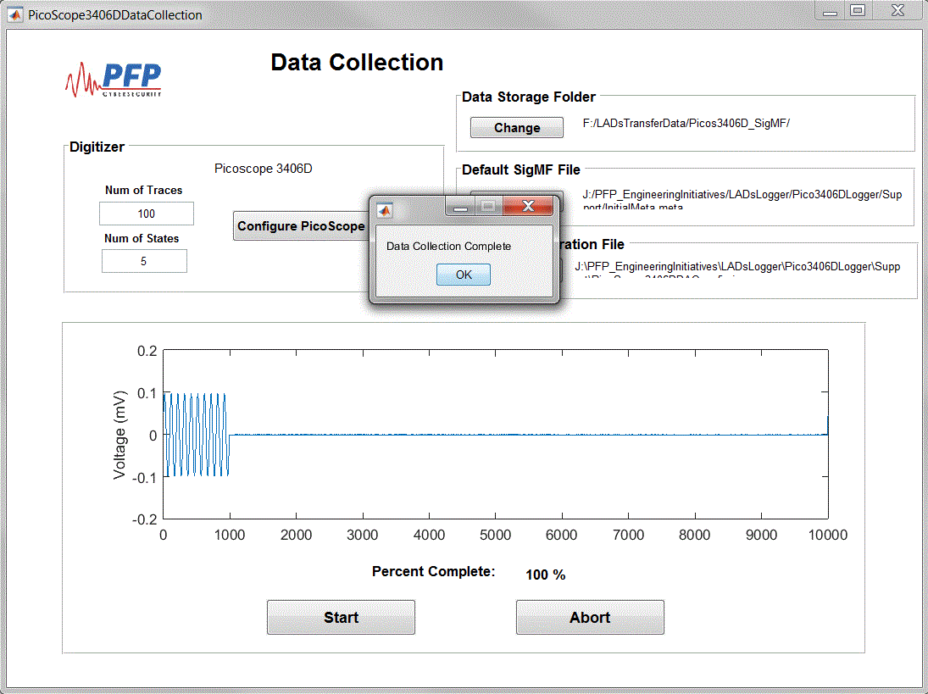

The logger application can be shut down by simply closing the GUI windows. When closing the GUI’s the user will be prompted to save the current configuration. This allows the user to keep an archive of various configuration for different application.

Streaming Mode

Back in step 7 the user also has the ability to select Streaming Mode Data collection. Below is the opening screen shot when Streaming mode is selected.

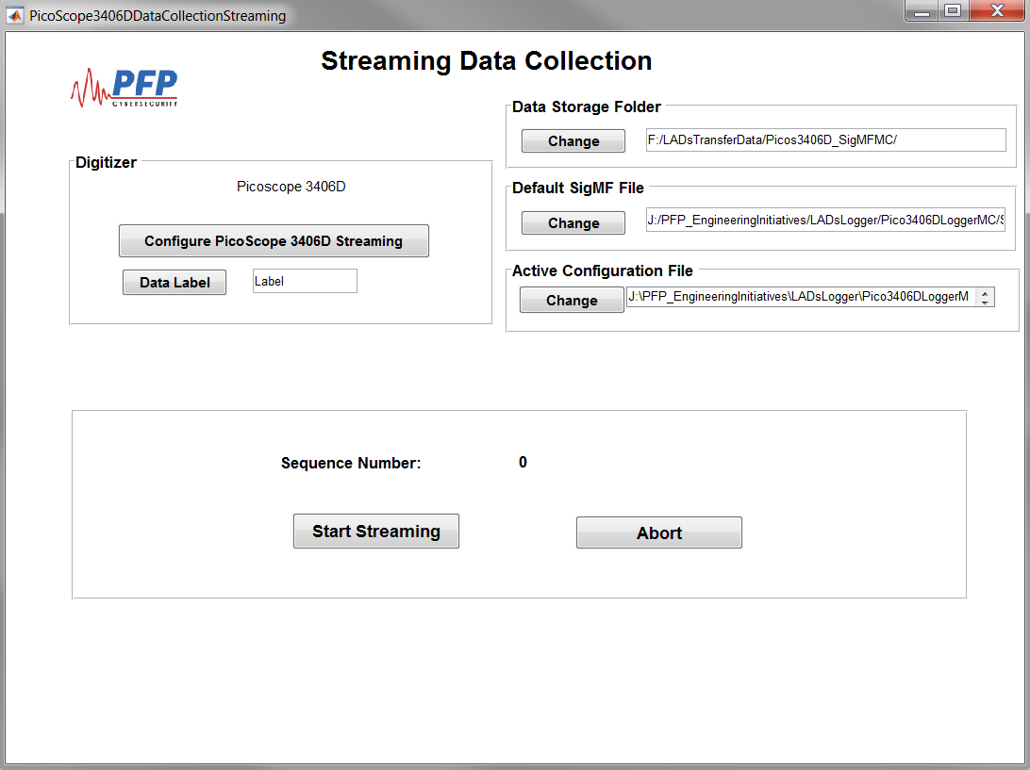

In Streaming mode the user still follows the instructions for configuring the PicoScope 3406D as outlined in step 8. Observations of the waveforms ensures that the PicoScope 3406D sampling parameters are properly configured for the user application. Once the user is satisfied with configuration the configuration GUI can be exited. The user has the option to enter a “Data Label” for the current data collection, this label is written to the SigMF Meta file for post processing identification. As the logger is acquiring data and writing to file, a sequence number output is provided for a visual indicator to the user that system is running.